Prompt: Are some types of knowledge more useful than others?
Theme: Knowledge and Technology

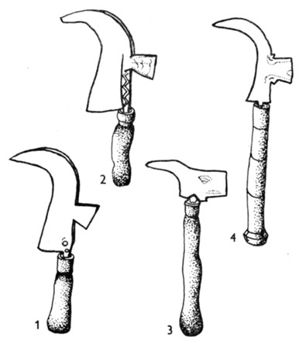
Ancient pruners
(In a real TOK exhibition I would use a real object, as I own a pruner like this)
http://mek.oszk.hu/02100/02115/html/img/5-097.jpg

The object I chose to investigate is a pruner from my own collection. This type had been used from Roman times in vineyards and was replaced by pruning shears only in the 20th century. It was a multifunctional tool used for cutting and chopping. Some could argue that it has no connection to our, modern, mostly urban lifestyle, and it is a typical piece of knowledge which the world no longer needs. Nevertheless, I am still proud of the knowledge of its usage and past. Why do I value it? Where does its usefulness lie? I am quite certain that it has no effect on my standards of living and even in the unlikely event of an apocalypses my survival would not depend on my knowledge about pruners. What is its use then? First, I think that understanding simple constructions and their functions can help us see how mechanical things work. In everyday life, we often need quick solutions, simple ‘life-hacks’, small household inventions for technical problems. Knowing of old technology might just incite the spark of a new idea for a new problem. Understanding technology does not just mean using computers but also having at least basic knowledge of mechanics. In addition to the technological knowledge, this little pruner also has an importance in understanding more about history. It serves as evidence that the Roman invasion had a cultural effect which lasted for more than 1500 years in the province of Pannonia. It teaches us about empires and their influence. Consequently, it cannot be stated that this knowledge is useless. However, can it be regarded as less useful than e.g. knowledge of tools for brain surgery? I think that, at least in theory, such comparisons are meaningless. Knowledge of high technology is based on knowledge of simple mechanics. Without them, more complicated technology would not exist.

